Story 03 - Book Filter - v3

Changes with respect to v2: see Acceptance Criteria and Technical Requirements

## Description

As a user

I want to filter the book overview

On price, title and color

## Wireframe

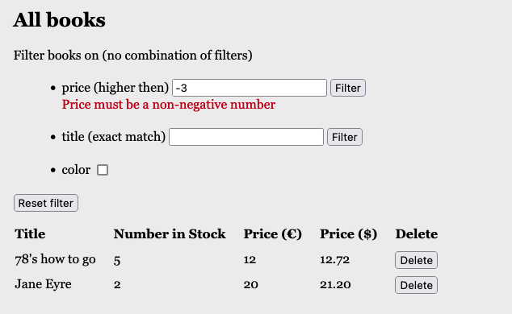

## Acceptance Criteria

* The screen shows three filter options
  1. Filter books on price: only books with price higher than given value are shown
  2. Filter books on title: only the book with the given title (exact match, not case sensitive) is shown
  3. Show only books that are in color (when check box is checked).
* Filtering only starts after clicking on the filter-button or checkbox.
* Filter values are shown in table overview
* If the filter value for price is a negative number, an error message is shown below the input field. The overview shows all books in the library.
* If the filter value for title counts less than 3 characters, an error message is shown.
* If the filter value for price or title is empty, the same error message as above is shown.
* Filters cannot be combined

## Technical Requirements

* Validation must be done in Service Class.
* When validation fails, a self-written ServiceException is thrown and caught in the REST controller.
* Output in Unhappy case has always response status 400 BAD REQUEST
* The books are stored in a h2 database.
* Search queries are performed in a jpa repository (no implementation of search in BookService).

## API

* API for “Filter Books on Price”

|  |  |
| --- | --- |
| **Filter Books on Price** | |
| **Request** | GET |
| **URL** | [http://localhost:8080/api/book/search/priceMoreThan?price={price}](http://localhost:8080/api/book/search/priceMoreThan?price=30) |
| **Input** | Price to be filtered as query string (number) |
| **Output: Happy Case** | JSON list of books |
| **Output: Unhappy Case** | * Empty list [] when there are no books found. * JSON error message:   "price-filter": "The search value must be a non-negative number" |
| **Acceptance Criteria** | Returns all books with price more than the given price. |

Tip: <https://www.baeldung.com/spring-request-param#a-default-value-for-the-request-parameter>

* API for “Filter Books on Title”

|  |  |
| --- | --- |
| **Filter Books on Price** | |
| **Request** | GET |
| **URL** | http://localhost:8080/api/book/search/title/{title} |
| **Input** | Title to be searched as path variable |
| **Output: Happy Case** | JSON *list* of books (<> book object!) |
| **Output: Unhappy Case** | * Empty list [] when there are no books found. * JSON error message:   "title-filter": "Title must have at least 3 chars" |
| **Acceptance Criteria** | Returns the books with given title as list of JSON book objects |

Tip: <https://www.baeldung.com/spring-pathvariable#making-an-optional-path-variable>

* API for “Show Books in Color”

|  |  |
| --- | --- |
| **Show Books in Color** | |
| **Request** | GET |
| **URL** | <http://localhost:8080/api/book/search/inColor> |
| **Input** |  |
| **Output: Happy Case** | JSON list of books |
| **Output: Unhappy Case** | Empty list [] when there are no books found. |
| **Acceptance Criteria** | Returns all books in color |